Radnor Office Desk Setup Guide
Please follow the instructions below.
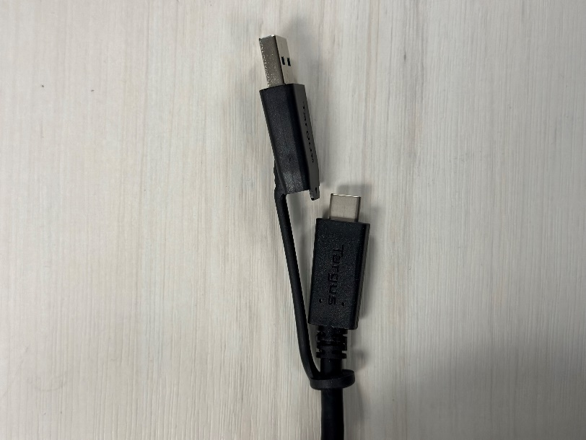
- Find an available desk that does not appear to be in use or an office that has not been reserved. Then locate your dock and docking table.
- The dock cable has a USB-A and C option. We recommend using USB-A only if you do not have USB-C ports available on your machine.
- If it is not already available, expose the USB-C connection by pulling on the USB-A connection until it comes off.
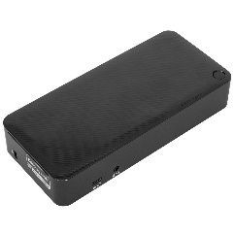

If Your Monitors Are Not Connecting
Once you have connected your laptop to the dock, the monitors should populate. If you are having issues, please try the troubleshooting steps below.
- Ensure that your monitor is on the “DP” or “DisplayPort” input channel.
- Press the WinW and “P” keys simultaneously to pull up the display settings menu and select “extend.”
- Install the “Totu Drivers” Package in the Software Center.
- Restart your machine.
- If you are still unable to connect, please contact CorpOps to assist you further.
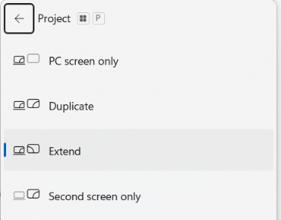
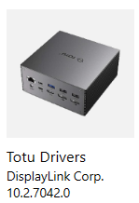

If Your Monitors Are Duplicated
If you are using 2 monitors or one wide monitor with your open laptop and all of your monitors are displaying the same duplicated screen, press WinW + P to pull up the display settings menu and select “extend.”

If Your Monitors Are Not in Your Desired Order
If your mouse does not move between monitors how you would prefer, right click on the desktop of any of your monitors and select ‘Display Settings.’
From the following screen, you will be able to click, drag, and rearrange your windows in any way you would like. You can use the “Identify” button to have an indicator appear on each monitor that corresponds to the on-screen numbered panels. Be sure to hit apply when you are done to save your changes.
