Accessing Skillsoft Content in DIG
More than 4,000 Skillsoft learning activities are now accessible in DIG. You can search for Skillsoft content in Library or using enterprise search in the header. Instructions for accessing are outlined below.

Library Search

- Click on the Library icon in the control panel:

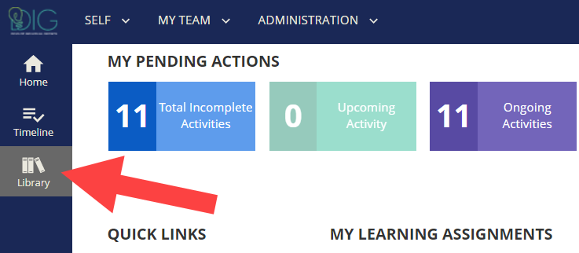

- A topic titled Skillsoft Content has been added to the library. Click the arrow ( > ) to the left of the Skillsoft Content title to display the available topics.

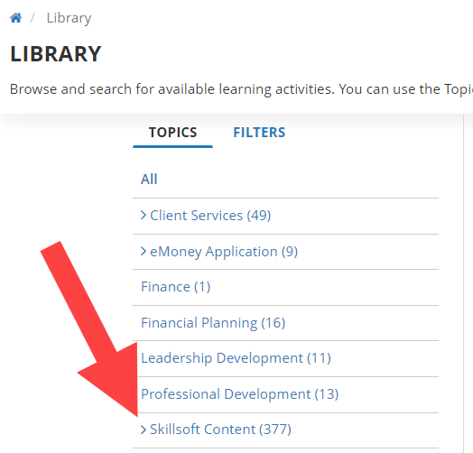
- The Skillsoft library is displayed showing numerous topical areas. in two activity types, Bundles and Journeys. Click the arrow ( > ) to the left of a topical area to view the available sub-topics.

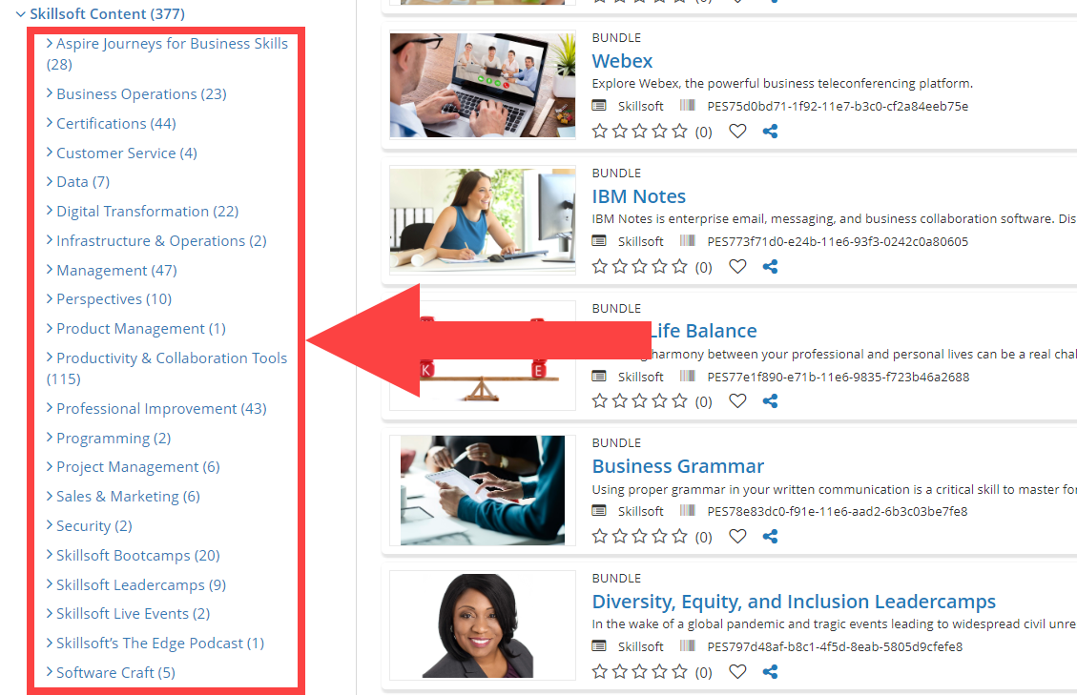

- The available options are displayed in two primary activity types, Bundles and Journeys.

Bundles: A bundle is a grouping of online courses by topic that you can access all in one place. For example, you can find a bundle called "Presentation Skills" listed in the Business Communication sub-topic which has several online courses like "Public Speaking Essentials" and "Using PowerPoint" associated with it.

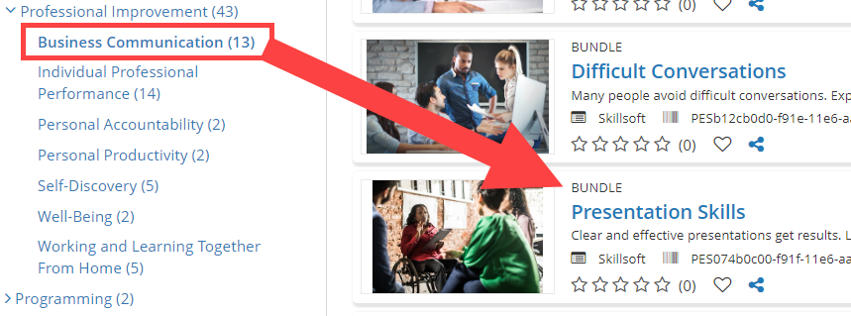

Bundles are not individual activities. You cannot register for or "complete" the bundle itself. Instead, think of them like little libraries containing related activities you can launch and finish. Click the Bundle title to view the contents and click Start Course to launch the desired online course.

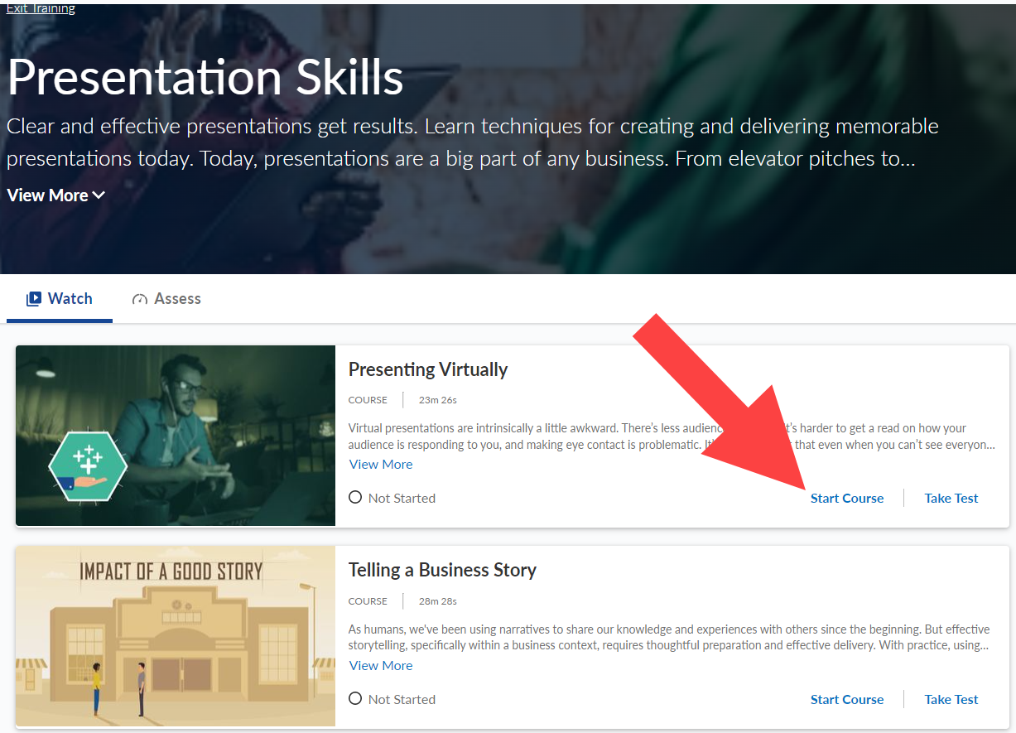

To exit the bundle and return to the Library click Exit Training in the upper left corner.

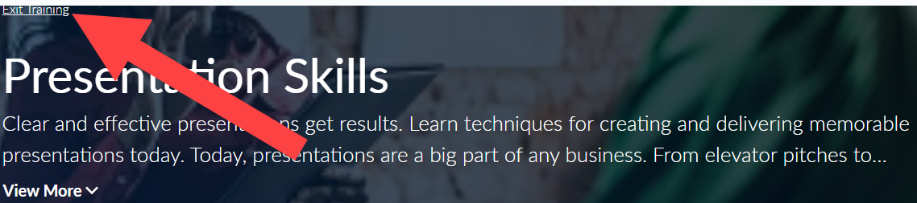

Journeys: Journeys are structured learning paths. A journey keeps you working toward an overall goal, helping you to achieve your career aspirations. Each stage takes you step-by-step through a diverse set of topic areas. As you move along the path, each journey builds upon your current knowledge allowing you to broaden and strengthen your skills.

Journeys are made up of required tracks, which contain all of the learning content for a specific path or job function, as well as any optional resources. To complete a journey, you must complete ALL of the tracks within the learning path. Click on the title of the journey to view the details.

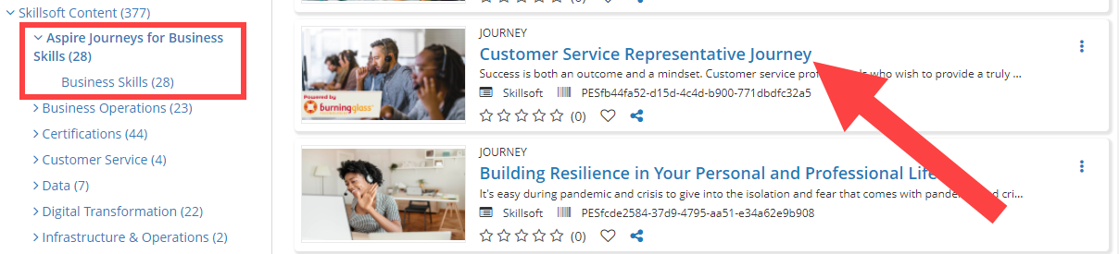

Click <START> to access the journey.
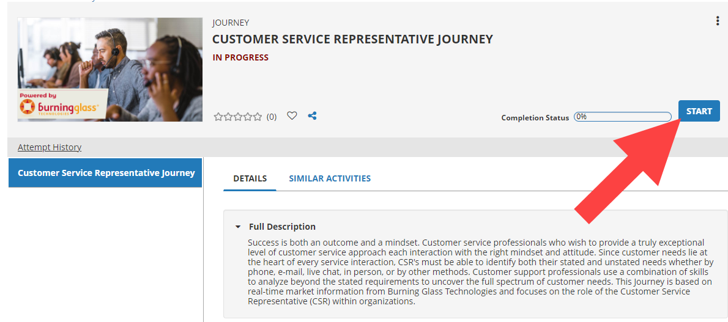

Upon opening the journey, the required tracks will be displayed. You can also see the total number of courses and expected time to complete.
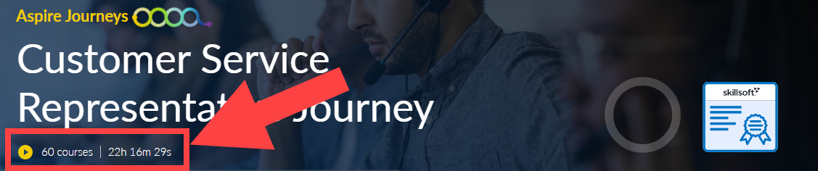

The required tracks will be listed under the journey descriptions. Click on Explore to begin a track.
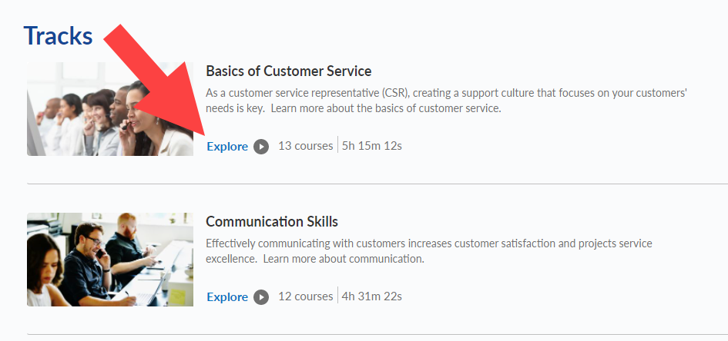
The list of courses included in the track will be listed in the sequence that they are to be completed. Click <Start Course> to open the course.

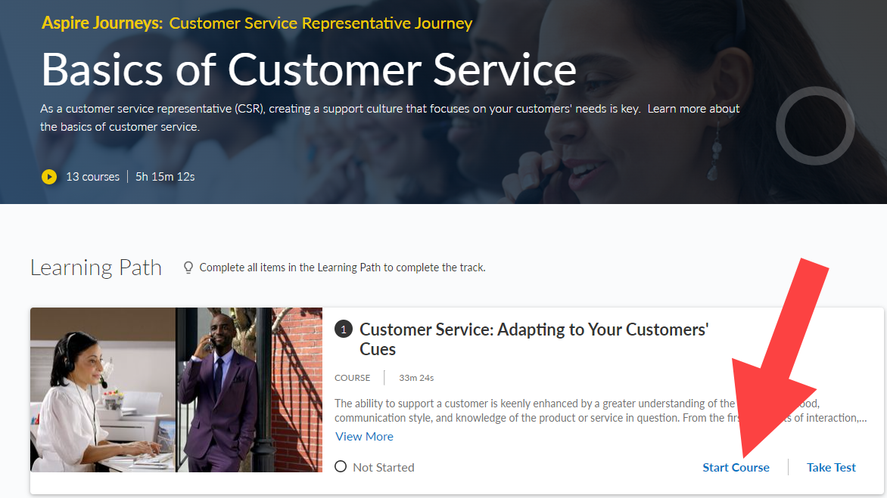

The course will open within DIG. You can return to the track and Journey at any time by clicking on <Return to Track>.
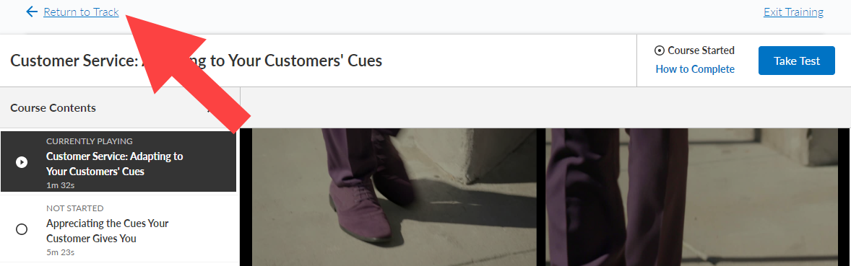
From the track you can exit training or return to the journey at any time using the links in the upper left corner of the track.
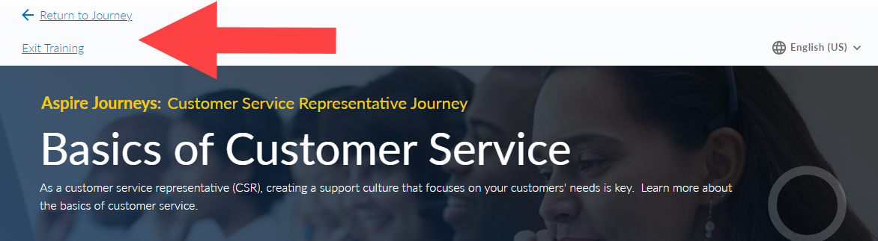

Live Events: The Skillsoft library also provides you with access to live events. Click on Skillsoft Live Events.
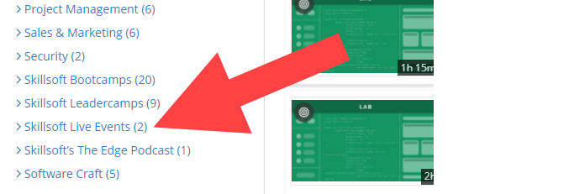

Two bundles will be displayed, Upcoming Live Events and On-demand events.

Clicking on Upcoming Events will display of upcoming live webcasts featuring industry experts, thought leaders, best-selling authors and business school faculty on a variety of topics. You can select an upcoming event to add to your calendar.

Clicking On-Demand Events will display a list of previous live webinars that can be accessed and watched as you desire.

Enterprise Search

You can also access all of the Skillsoft content using the Enterprise search feature in the DIG header. Simply enter the search criteria for your topic of interest and a list of options will be displayed.
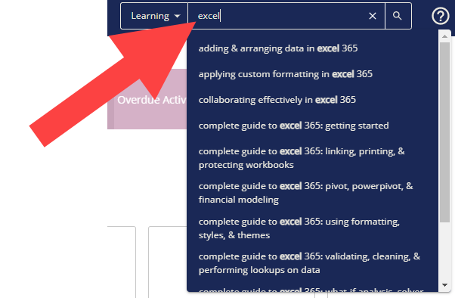

Click the desired option and select the online course from the search results.

